React Components
- In React JS, Components are independent and reusable pieces of code and also called building blocks of react app.
- In React JS, they serve the same purpose as JavaScript functions, but work in isolation (separately) and return HTML or HTML elements.
- In React JS, Components are of two types
  - Class components
  - Function components
- In this Blog, we will concentrate on Function components.

Functional Components In React JS
- Components are just like functions that return HTML elements.
- In older React code bases, you may find Class components primarily used.
- In React JS, it is now suggested to use Function components, which were added in React 16.8.

Understanding WorkFlow Of React APP


1st Way Of Working With Functional Components
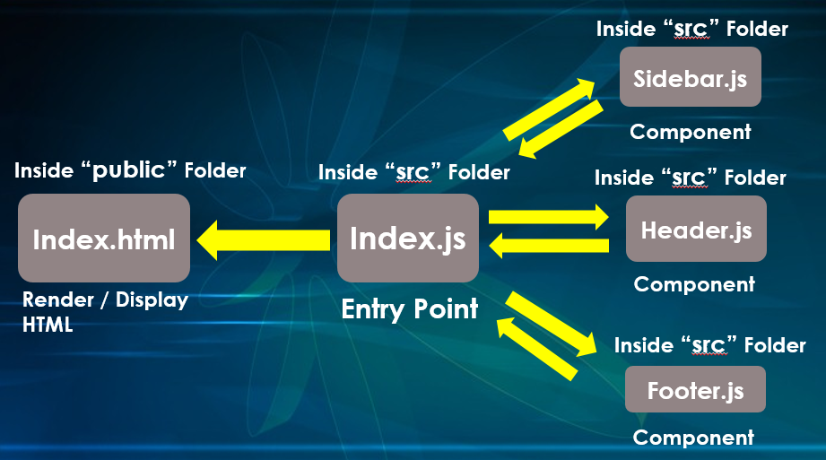

2nd Way Of Working With Functional Components
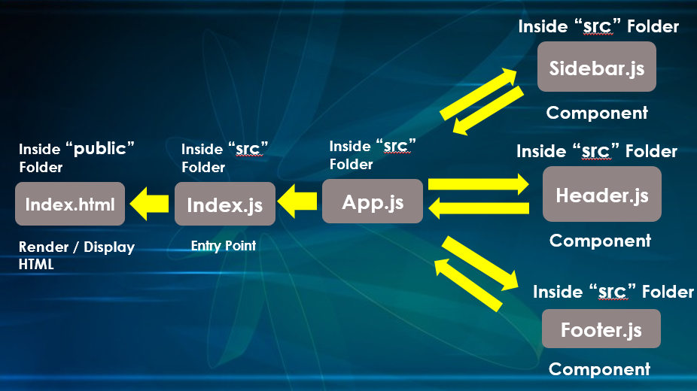

1st Way Of Working With Functional Components – Code

Header.js Component

